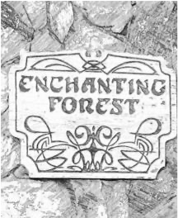

Enchanting Forest Owners Association Please complete and return with payment.
Enchanting Forest Owners Association Post Office Box 903 Morganton, Georgia 30560
Membership Dues - Please pay by September 30, 2023.
$200.00 per vacant lot
$350.00 per lot with cabin/house
$500.00 per lot with vacation rental cabin/house
Name: ________________________________________________________________
Mailing Address: ________________________________________________________
Email Address: _________________________________________________________
Enchanting Forest Lot Number(s) or address: _______________________________
Amount Enclosed: $_____________________

